CURRICULUM VITAE

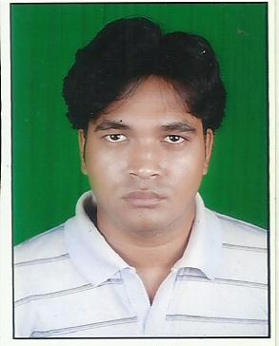

MANOJ KUMAR SAHOO
S/o. Dandadhar sahoo
Gurgaon,sector-10
Gali no-4,om nagar
Mob : 7210076030,
9778632078
Email : manojsahoo954@gmail.com

CAREER OBJECTIVE :
To establish myself for a long term association with a people oriented organization where my knowledge, interpersonal skill, monitoring manpower and indefatigable approach towards work would be exposed to gain expertise and acknowledged for both organizational and individual growth.

EDUCATIONAL QUALIFICATION:
Examination Passed | School/College | Board/ University | Year of Passing | % of Marks
Matriculation | Deepika English medium school | C.B.S.E | 2008 | 53%
Diploma (electronics & telecommunicatioin engineering) | Sundargarh engineering school,sundargarh | S.C.T.E. & V.T. Orissa | 2011 | 62%
b.tech  (electronics & instrumentation Enggineering) | Kiit university, bhubaneswar | Deemed university | 2014 | 61%

COMPUTER KNOWLEDGE:
- All windowa until windows xp
- Computer hardware & networking
- C++
- PLC
TRAINING & PROJECTS :-
- Undergone vocational training in S.A.I.L(R.S.P).
- Undergone vocational training in webel informatics ltd.
SUMMARY OF SKILLS:
- Good communication skills.
- Willingness to learn.
- Forward planning and ability to priorities.
- Analytical thinking capability.
- Zeal and enthusiasm.
- Ability to deal with people diplomatically.

STRENGTH:
- Willing to take extra responsibilities to get the work done.
- Discipline and believe in hard work.
- Excellent Inter Personal Relationship Skill.
- Punctual and Sincere towards job.
- Adaptable to diverse working environments.
- Leadership abilities.

PERSONAL PROFILE :

- Name : MANOJ KUMAR SAHOO
- Father’s Name : Mr. Dandadhar sahoo
- Mother’s Name : Ms. Swarnalata sahoo
- Date of Birth : 10.07.1992
- Permanent Address : QR NO- A/265,sector-4
Rourkela – 769002
Dist: Sundargarh, Odisha

- Nationality : Indian
- Religion : Hinduism
- Sex : Male
- Marital Status : Unmarried
- Languages Known : English, Oriya & Hindi
- Experience : 2 Months in International Process
6 Months in Domestic Process
- Hobbies : Listening Musics & Making New Friends.

DECLARATION

I do hereby declare that the above-mentioned facts are true to the best of my knowledge and belief.

Place:

Date : / /

(manoj kumar sahoo)

